Manoj Vasa
4/6/2015
EBIO 2040-015 Principles of Ecology
The Influence of Prairie Dogs on Vegetation in Prairie Biomes
Abstract
The prairie biome consists of many organisms that interact with each other. Such interactions lead to dependencies that develop for the many species to keep living. Prairie dogs play a crucial role in this scenario. The unique greenery that prospers in this biome is affected by the prairie dog's influence. In the site we chose to study there were 5 prairie dog burrows. From the 5 burrows we scouted five random directions and five random distances away from the burrow. As we have gathered our results we found that most plants and greens were prevalent closer to a prairie dog burrow. As we distanced ourselves from the burrows we gradually saw less plants unless there was another burrow nearby. The most abundant greenery in the biome was grass. Total plant coverage also decreased in areas that were further away from the burrow. This concluded that prairie dogs contribute a positive influence to the ecosystem that they inhabit.
Introduction
In this study we are approaching the question as to if prairie dogs positively or negatively influence landscape ecology. The positive effects may result to the vegetation being closer to a burrow rather than further away as if there were a negative influence. We've hypothesized that prairie dogs convey a positive influence on the vegetation surrounding it. This positive influence may be that the prairie dogs may provide nutrients to the vegetation to grow or disperse seeds as to spread its growth. Prairie dogs may not approach to broad a radius to scavenge for food. In this case they may stay considerably close to their burrow. With this in mind the dispersal of seeds and nutrients may be considerably rich closer to the prairie dog burrow rather than far away.
Materials and Methods
After we gathered our data we tested the results in R. We entered in the data through excel and performed a regression test for each organism present in the area. This test seemed to be appropriate since t determines the line of best fit and indicates a trend in the data. This trend could consist of a decrease of the amount of vegetation or increase in some areas.
Results
figure 1. figure 2.
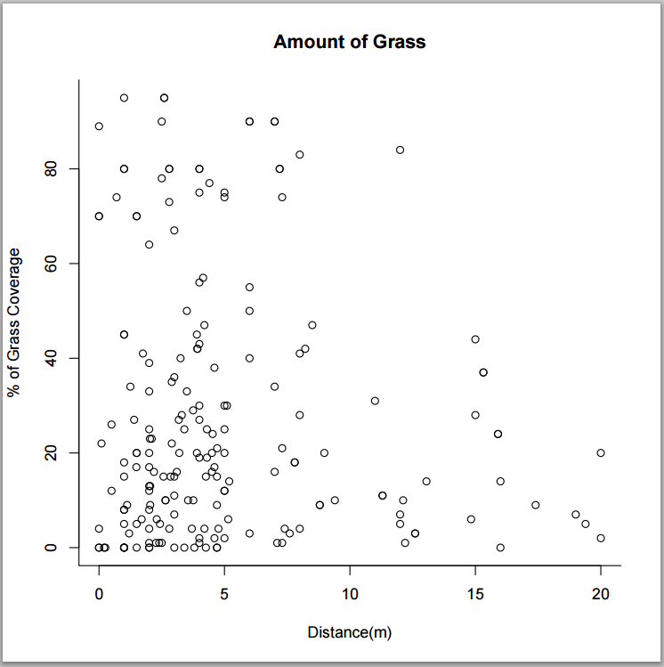
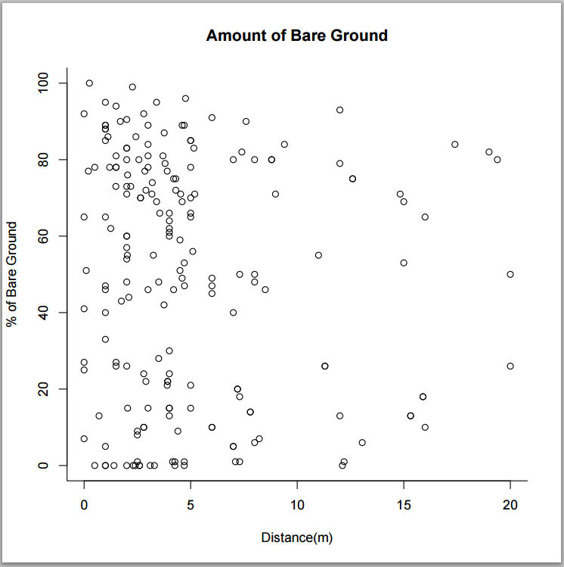
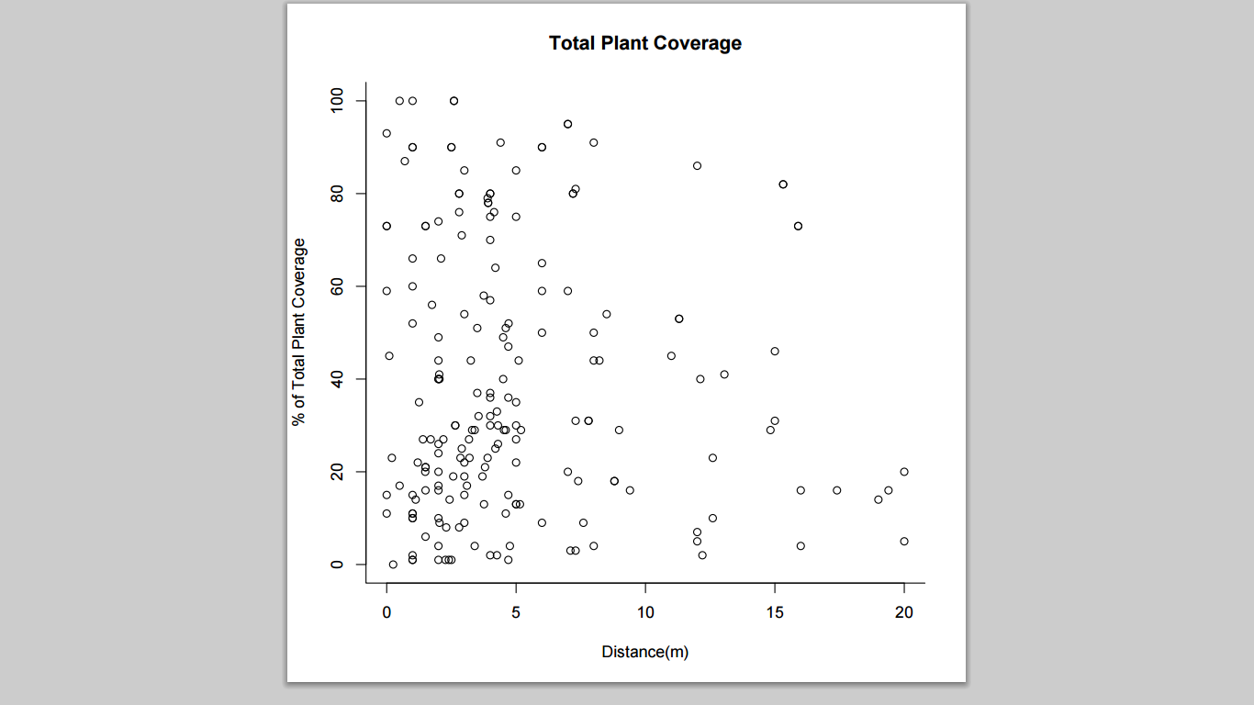
figure 3.
Figures 1-3: The figures above show the amount of greenery found around the burrows while also indicating their distance from the closest burrow.

As seen in figures 1 and 3 plant coverage seems to be more dense closer to the burrows. However there also seems to be a fair amount of bare ground close to the burrow. The R squared value for grass coverage was .008102, for total plant coverage was .001831, and for bare ground was .006651.
Discussion
This data supported the hypothesis that I formulated earlier. The amount of vegetation seems to be more dense towards the proximity of the burrows. There appears to be patches of ground consisting of various vegetation or bare ground. These bare ground patches seem to be more prevalent than the patches of vegetation by the burrow. However, there was more bare ground than plant coverage towards further distances from the burrow. The graphs portrayed this trend consistently. R squared values seemed to be very low for these graphs. This may be because of the density of vegetation doesn't imply a gradual decline. Rather, it portrays a high density on distances closer to the burrow and a drastic decrease of vegetation away from the burrow. Nonetheless, the amount of vegetation and bare ground could only be estimated. The measure used to consider if an area was grassy enough to be considered to have vegetation or if it was bare ground seemed biased. Various individuals may prefer unique measures as to what is bare ground and when there is enough vegetation. A better divide between bare ground and vegetation would've improved the data collected in this study.

